**DA Assignment – 2 Submission**

**Title:**  
**Supermarket Sales Dashboard**

**Submitted by:**  
**Name :** K. Satish Kumar

**Roll Number :** 23AT5A3203

**Institute Name :** G.Pullaiah College Of Engineering and Technology

**📊 Introduction**

**Objective:**  
To analyze the sales performance of a supermarket chain operating in three branches over three months using Tableau visualizations. The data contains customer demographics, purchase behavior, and sales figures.

**Tools Used:**

* Tableau Public/Desktop
* Supermarket Sales Dataset (Jan–Mar 2019)

**Dataset Source:**  
*Supermarket Sales (Kaggle / Classroom link)*

**🧹Data Cleaning in Tableau**

**Steps Performed:**

* Imported CSV dataset into Tableau
* Removed unnecessary columns:
  + *Invoice ID* (unique identifier not required for analysis)
  + *COGS* (already factored into other calculations)
  + *Date/Time columns* – not used in some dashboards
* Renamed field names for better clarity (optional)

**📉 Visualizations + Insights**

**🔷 1. Donut Chart – by Customer Type**

**Screenshot:**

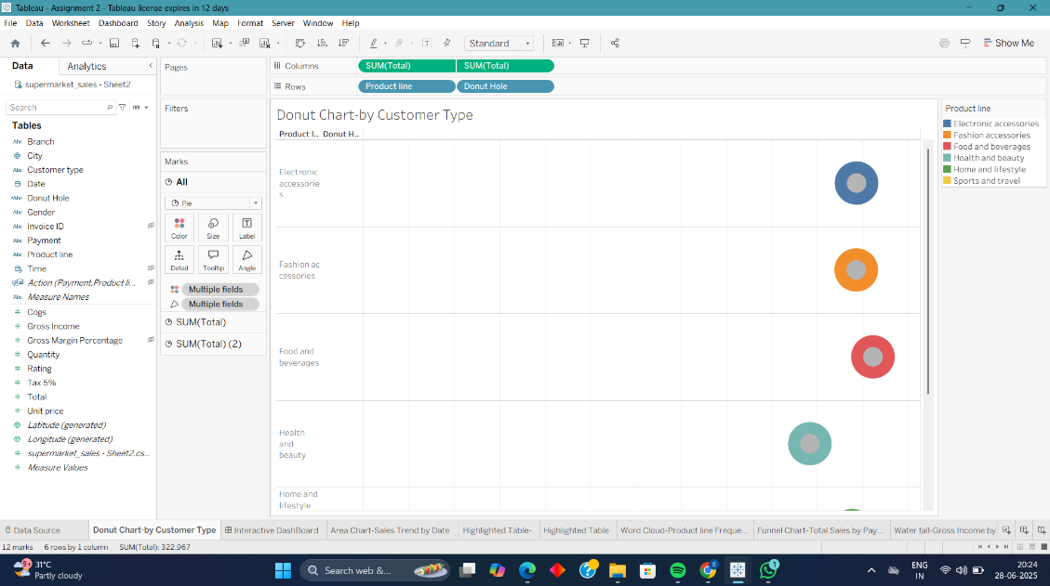

**Purpose:** **Compare values across categories** — specifically, to visually compare total sales performance by branch.  
**Best Attribute Combination:**

* **Dimension**: Branch (A, B, C)
* **Measure**: Total (or you can also use *Gross Income* for profitability insight)

📌 **Example:**  
**Chart Title:**

**"Total Sales by Branch"**

* **X-axis (Category)**: Branch
* **Y-axis (Value)**: Total Sales *(Sum of Total)*
* **Chart Type**: Donut Chart

**Insight**:

**Branch C** has the highest total sales, followed by **Branch A** and **Branch B**.  
This may be due to **greater customer traffic**, **larger purchase volumes**, or **branch-specific promotions**.

**✅ 2. Area Chart-Sales Trend by Date**

**Screenshot:**

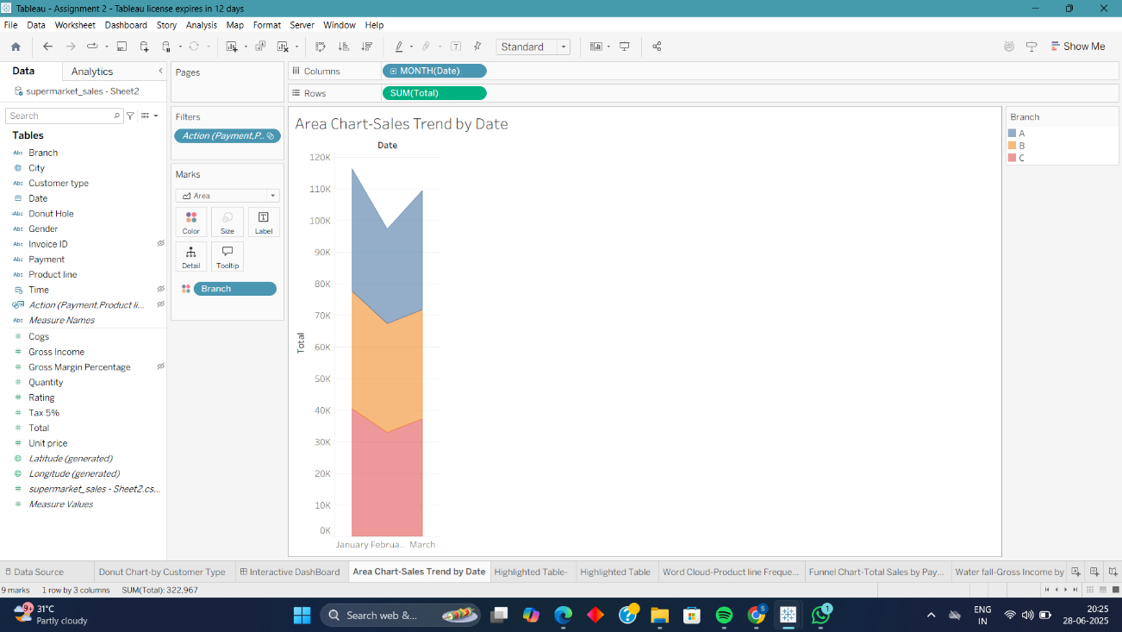

**Purpose:** **Show trends over time** — to visualize how a measure (like total sales) changes across a continuous time period.  
**Best Attribute Combination:**

* **Dimension**: Date (e.g., Date, Invoice Date, or Month)
* **Measure**: Total Sales or Gross Income

📌 **Example:**  
**Chart Title:**

**"Monthly Total Sales Trend"**

* **X-axis**: Invoice Date (Month or Day)
* **Y-axis**: Total Sales *(SUM of Total)*
* **Chart Type**: Area Chart

💡 **Insight:** Sales show a steady increase from **January to March**, with a noticeable spike in **February**, possibly due to seasonal demand or promotional campaigns.

**✅ 3. Text Table: Sales by Branch and Product Line**

**Screenshot:**

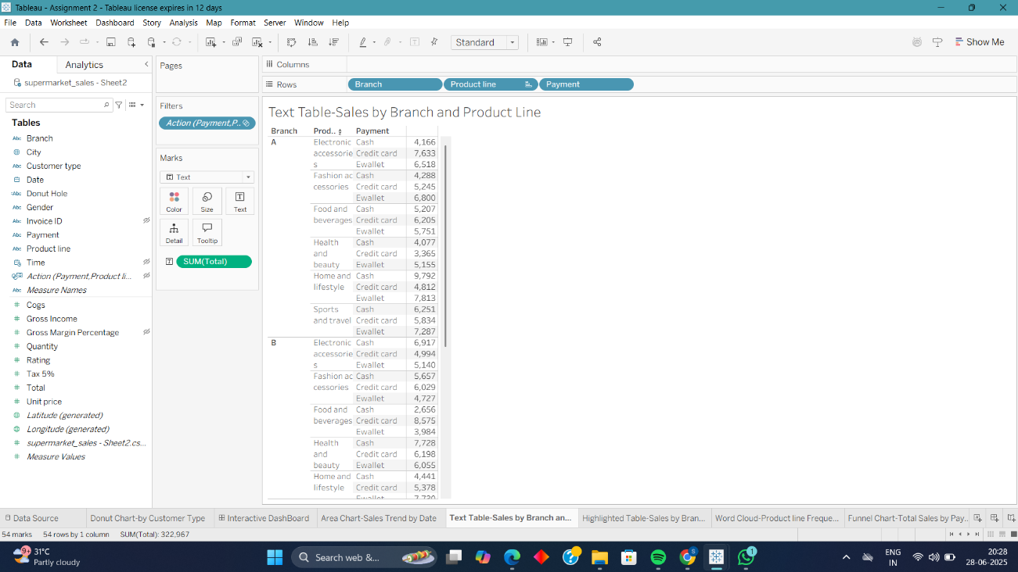

**Purpose:** **Display exact values in a tabular format** — ideal for detailed comparison of numeric values across multiple categories.

**Best Attribute Combination:**

• **Dimension**: Branch, Product Line, or Gender

• **Measure**: Total Sales, Gross Income, or Quantity

📌 **Example:**  
**Chart Title:**

**"Total Sales by Product Line and Branch"**

* **Rows**: Product Line
* **Columns**: Branch
* **Text**: Total Sales *(SUM of Total)*
* **Chart Type**: Text Table

💡 **Insight:** The **Food and Beverages** product line in **Branch C** has the highest total sales, while **Health and Beauty** in **Branch A** has the lowest.  
This helps identify strong and weak product categories by location.

**✅ 4. Highlighted Table: Sales by Branch ,Product and Payment**

**Screenshot:**

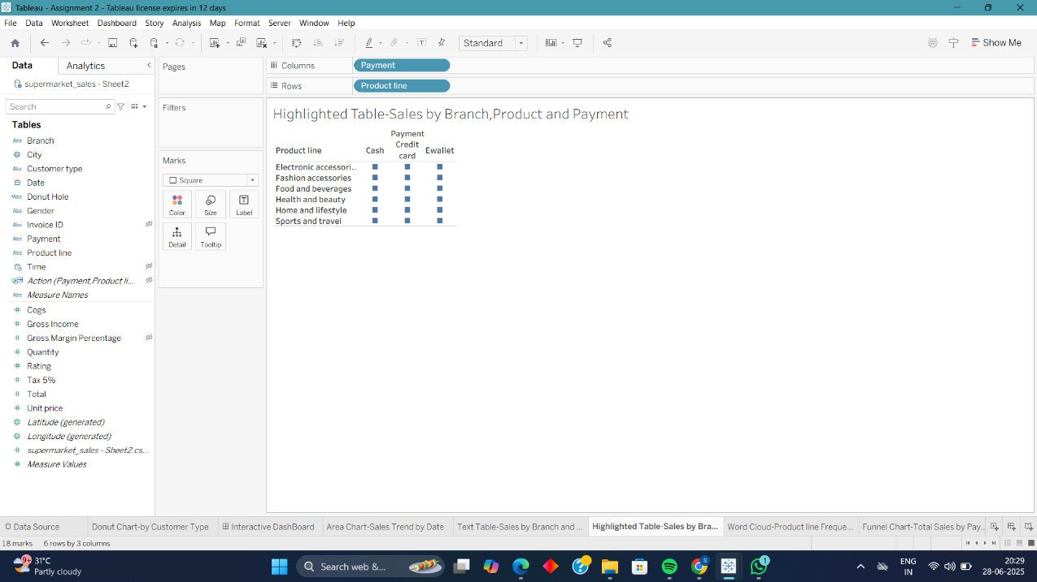

**Purpose:** **Compare values and emphasize differences** using color intensity — helps highlight high and low values in a table for better visual analysis.

**Best Attribute Combination:**

**• Dimension: Product Line, Branch, or Gender**

**• Measure: Total Sales, Gross Income, or Quantity**

📌 **Example:**  
**Chart Title:**

**"Gross Income by Product Line and Branch"**

* **Rows**: Product Line
* **Columns**: Branch
* **Text**: Gross Income *(SUM)*
* **Color**: Gross Income *(SUM)*
* **Chart Type**: Highlight Table (Text + Color Gradient)

💡 **Insight:** **Branch C** and **Food and Beverages** have the highest **Gross Income**, indicated by the **darkest color cell**, while **Branch A** and **Health and Beauty** have the lowest, shown in lighter shades.  
This color contrast quickly shows performance variations across categories.

**✅ 5. Word Cloud: Product Line Frequency**

**Screenshot:**

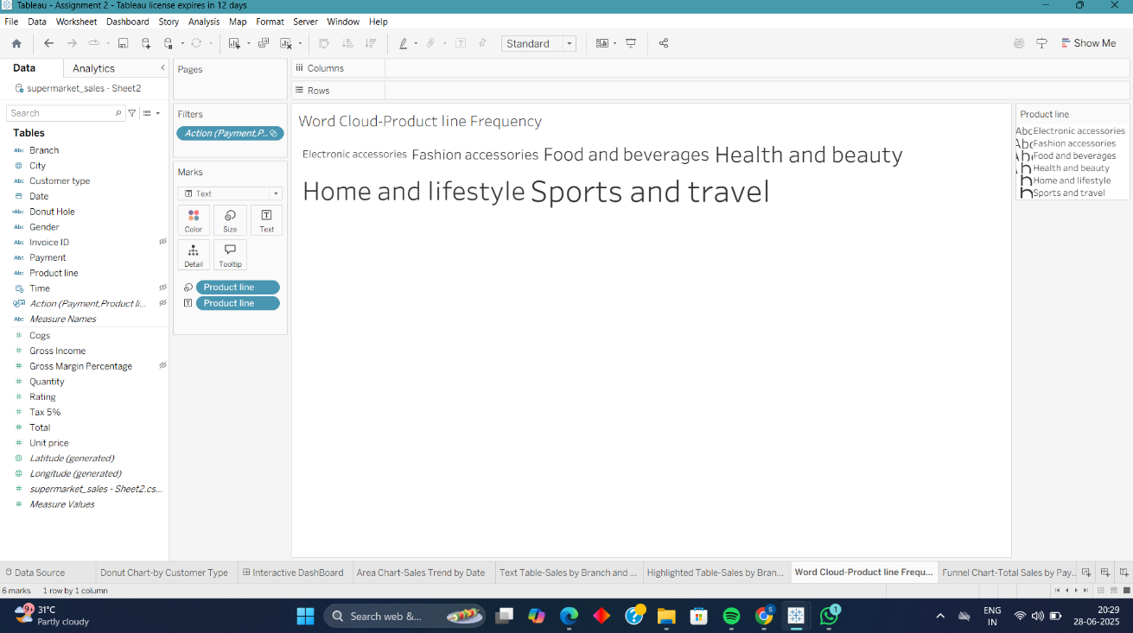

**Purpose:** Visualize the frequency or impact of categorical data

📌 **Example:** **"**Sales Volume by Product Line"  
💡 **Insight:** "Food and Beverages"

**6.Funnel Chart:** **Total Sales by Payment Method**

**Purpose:** Visualize progressive stages in a process and how values decrease or filter through each stage — ideal for showing conversion or drop-off rates.

**Screenshot:**

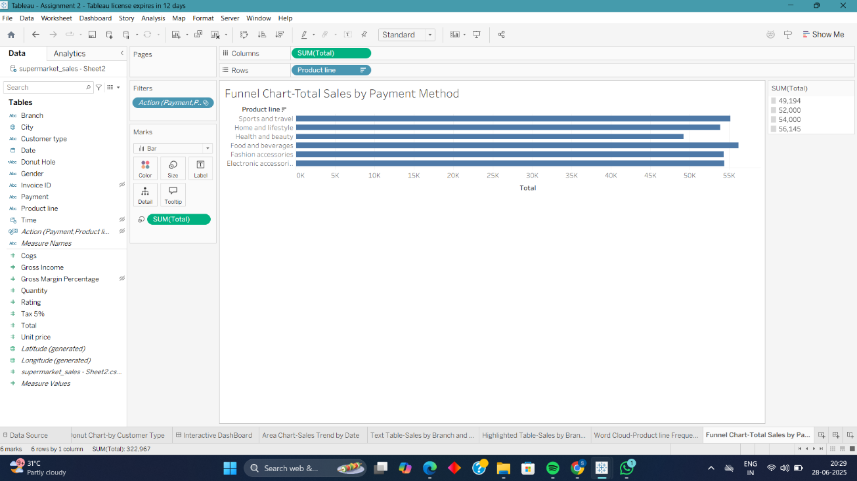

**Example:**

Chart Title:

"Total Sales Funnel by Product Line"

**Insight:** “Food and Beverages”

**7.WaterFall:Gross Income By Product Line**

**Purpose:** Show the cumulative effect of sequential positive and negative values — ideal for analyzing how individual components contribute to a total.

**Example:**

**Chart Title:**

"Gross Income Contribution by Product Line"

**Screenshot:**

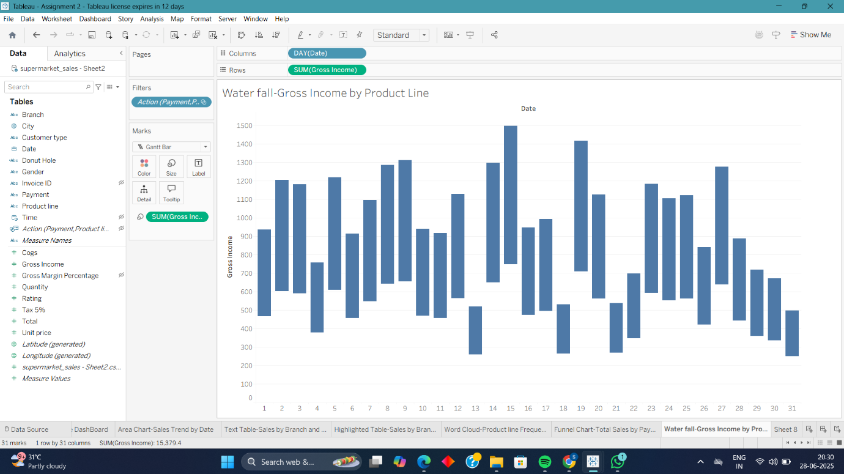

**🧾Conclusion**

* Visualizations reveal valuable insights about branch performance, customer preferences, and sales behavior.
* Tableau helped quickly identify patterns such as peak sales periods, product popularity, and preferred payment methods.